Name of Student: HARPAL BIDAWAT | PRN:25070122080
Semester: III | Year: AY 2026-27
Subject: Programming with Java
ASSIGNMENT No: 28
TITLE: Develop a Java application demonstrating Remote Method Invocation (RMI) using stub and skeleton components for remote communication
Problem Statement
Develop a Java application demonstrating Remote Method Invocation (RMI) using stub and skeleton components for remote communication.
Learning Objectives
To implement Remote Method Invocation for distributed Java applications.
Programme
1. Create a remote calculator service using Java RMI
2. Create a Java application using RMI where the server converts temperature values between Celsius and Fahrenheit. The client sends input temperature and receives converted output.

1)
Calculator.java
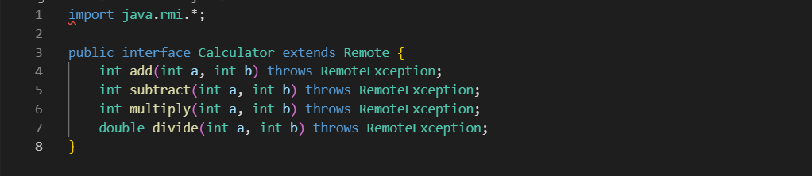
calculatorClient.java
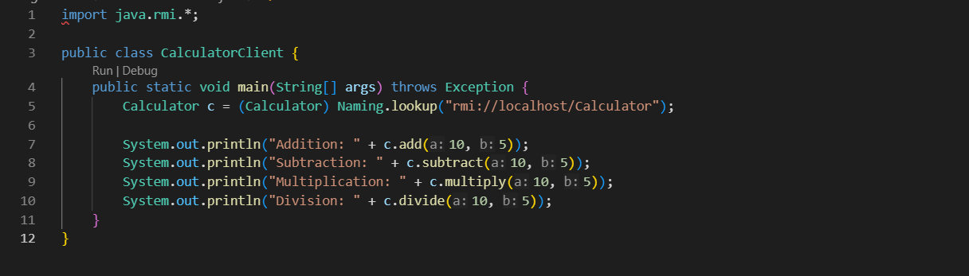

CalculatorImpl.java
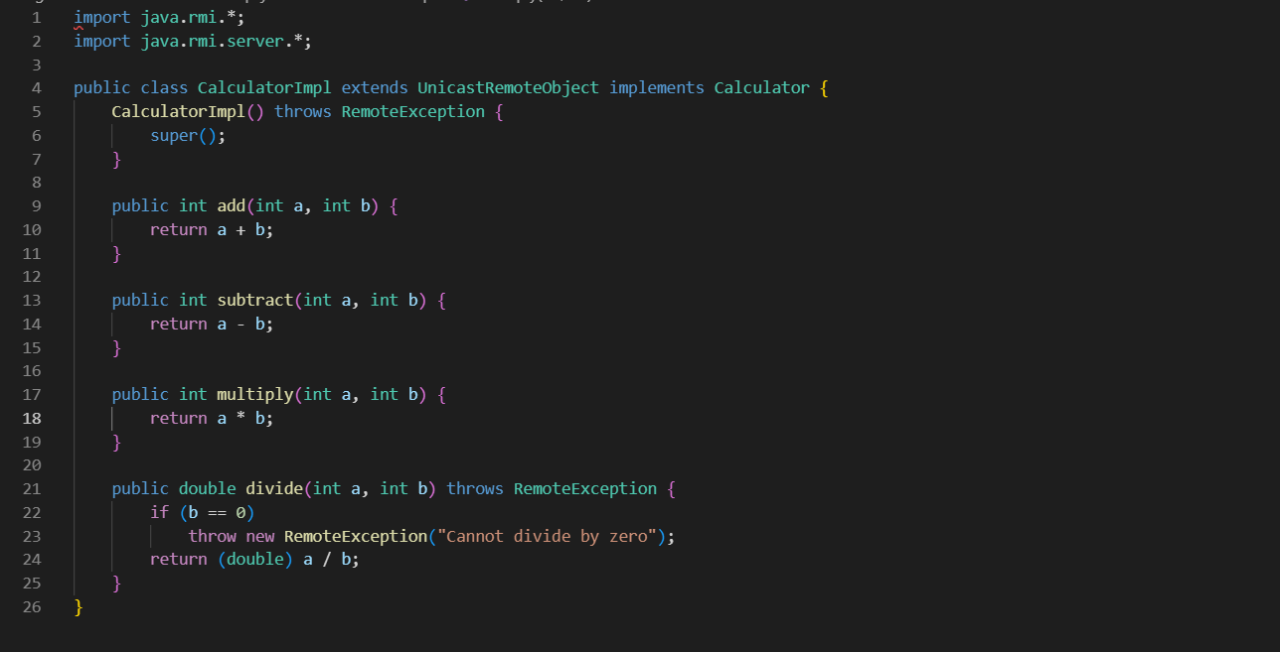

CalculatorServer.java
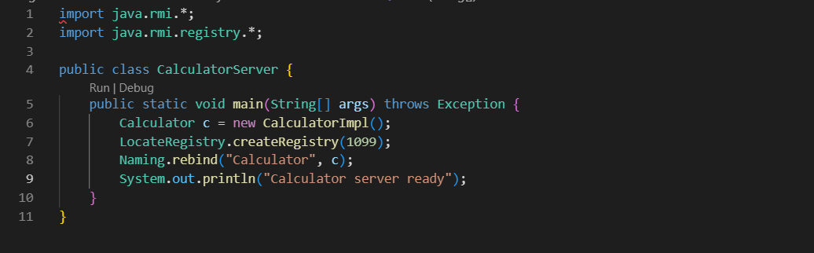

2)
Temperature.java
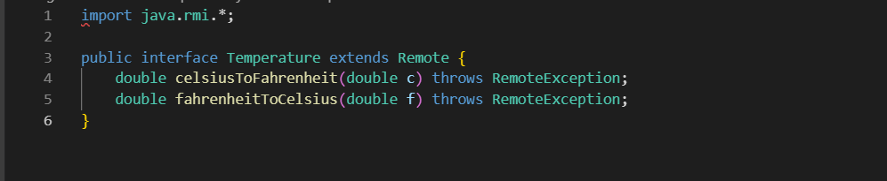
TemperatureClient.java
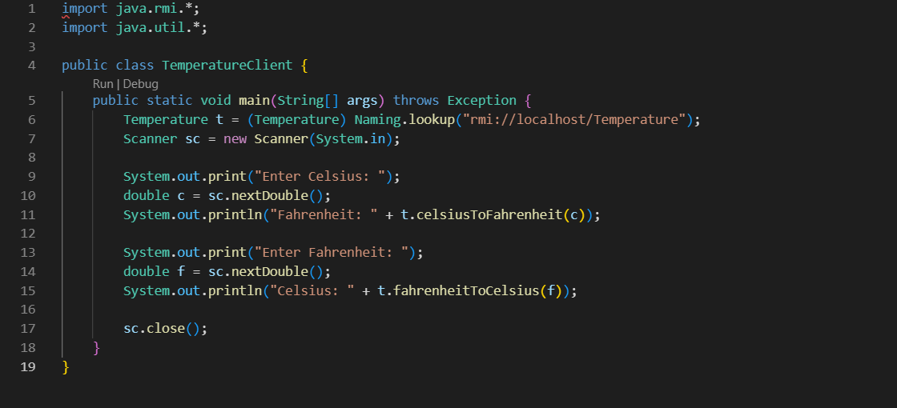
TemperatureImpl.java
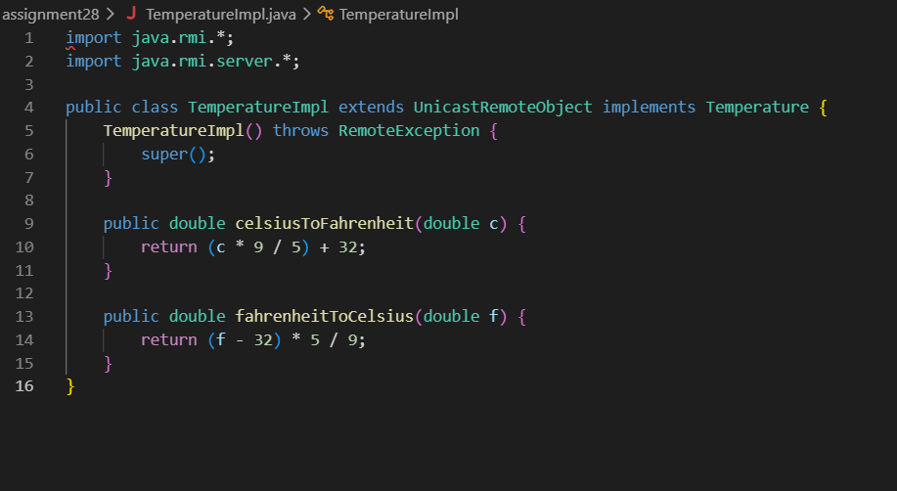
TemperatureServer,java
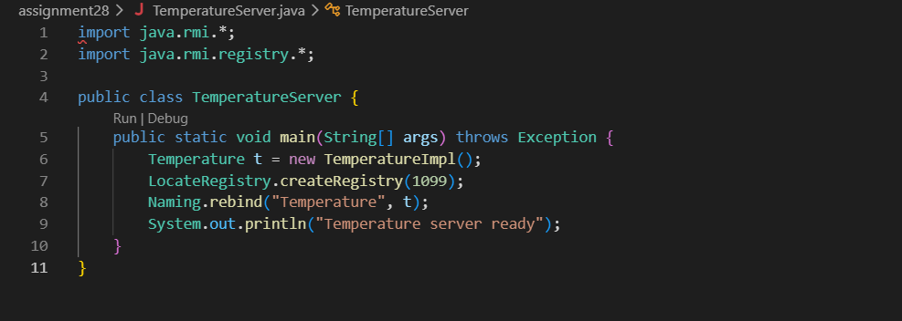
Output
1)
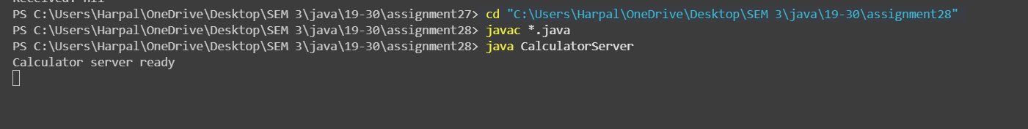
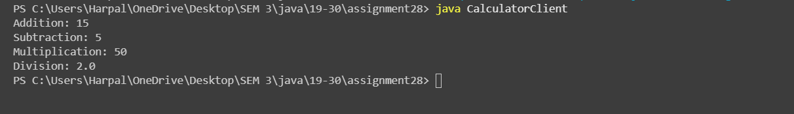
2)
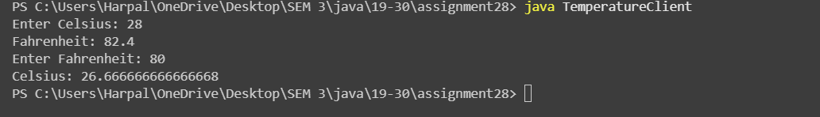
Conclusion

